# **Housing Society Management System**

**Members:**

***Vashisth Zatakia 60003200163***

***Yash Brahmabhatt 60003200159***

***Nupur Upadhyay 60003200160***

**Repository Link:**

**PROBLEM STATEMENT:-**

Many societies face the difficulty of getting certain information to be circulated among all the residents. The contacts of local helpers like electricians, carpenters etc. are difficult to find, especially on being a new occupant in the society. Catering to a well-established communication among the society as a whole, our website aims to the efficient flow of regulation inside a society.

**FEATURES IMPLEMENTED:-**

We have a **home page** which shows structure and basic look of the whole society as well as the celebration/events that takes place in the society. Home page also includes the message from the secretory and the chairman

Then we have the **announcement** which provides with additional notice by the society management system .

Next, we have **Reach Us** which shares the location of the society which helps the user to locate it quick .

We have a **login form** where every new member in the society can be part this web site.

Under **Admin** section we have maintenance , queries ,announcement, complaints:

**Functionalities:**

1. **Maintenance :-** Here, it displays the information of every flat whether they have paid their maintenance or not.
2. **Queries:-** It displays the query as well as the they’re with the contact details to solve the query.
3. **Announcement:-** The admin can add any announcement which will reflect on the main announcement page.
4. **Complaints:-** The complains of the user will be displayed in this section.

Under **user** section we have the following:-

**Functionalities:**

1. **Maintenance Log:-** it can be updated by user by adding the cheque no. , flat no. and it also shows whether the payment is confirmed or not.
2. **Raise A Complain** :-A flat can raise a complaint by describing it and specifying the flat number.
3. **General Contacts**:-It contains general contacts such as plumber, an electrician ,a security guard etc.

**TECHNOLOGIES USED IN THE PROJECT :-**

**Frontend:**

1. **Html:-** The Hypertext Markup Language or HTML is the standard markup language for documents designed to be displayed in a web browser. It can be assisted by technologies such as Cascading Style Sheets (CSS) and scripting languages such as JavaScript.
2. **CSS:-** Cascading Style Sheets (CSS) is a stylesheet language used to describe the presentation of a document written in HTML or XML (including XML dialects such as SVG, MathML or XHTML). CSS describes how elements should be rendered on screen, on paper, in speech, or on other media.
3. **Js:-** JavaScript (JS) is a lightweight, interpreted, or just-in-time compiled programming language with first-class functions. While it is most well-known as the scripting language for Web pages, many non-browser environments also use it, such as Node.js, Apache CouchDB and Adobe Acrobat.
4. **React:-** React makes it painless to create interactive UIs. Design simple views for each state in your application, and react will efficiently update and render just the right components when your data changes.

**Backend:**

1. **Django :-** Django is a high-level Python web framework that encourages rapid development and clean, pragmatic design. Built by experienced developers, it takes care of much of the hassle of web development, so you can focus on writing your app without needing to reinvent the wheel. It’s free and open source.

**SCREENSHOTS :-**

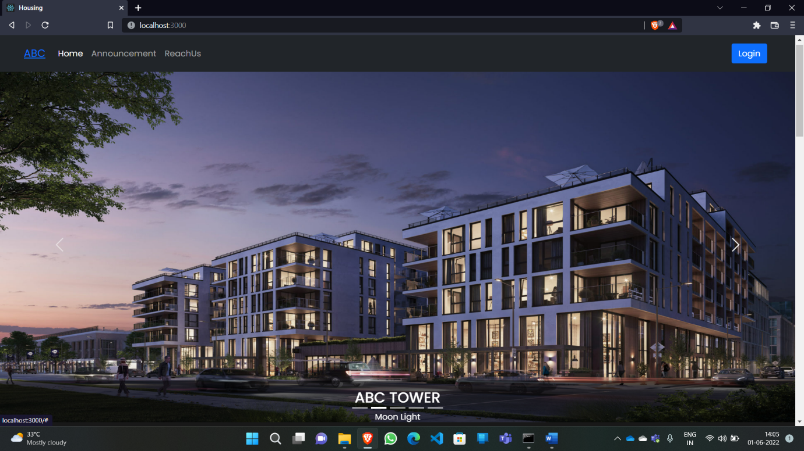

**Landing Page**

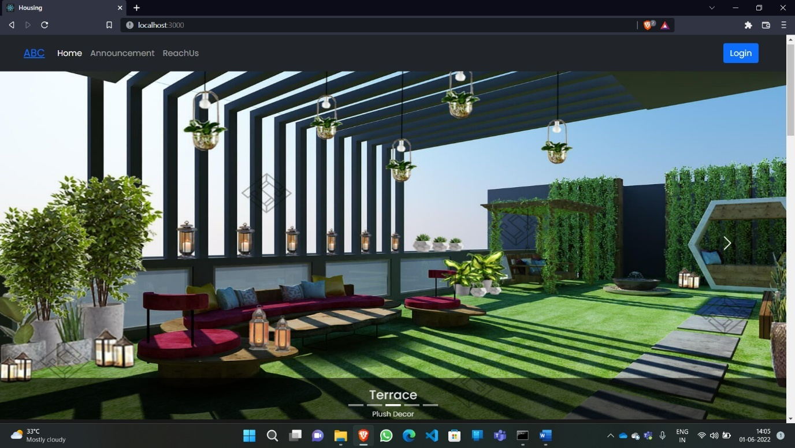

**Landing Page**

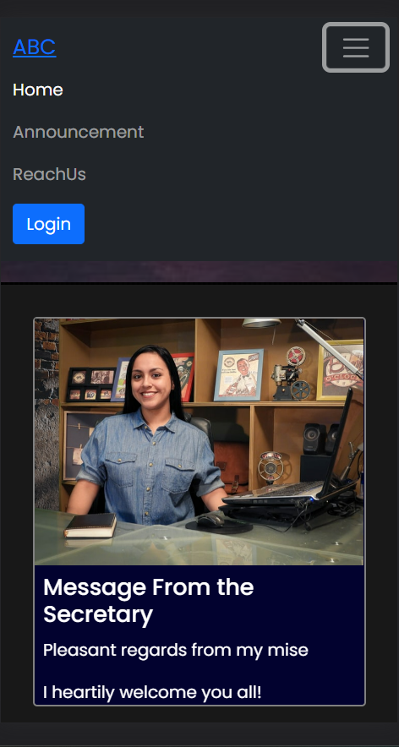

**Landing Page(Mobile View)**

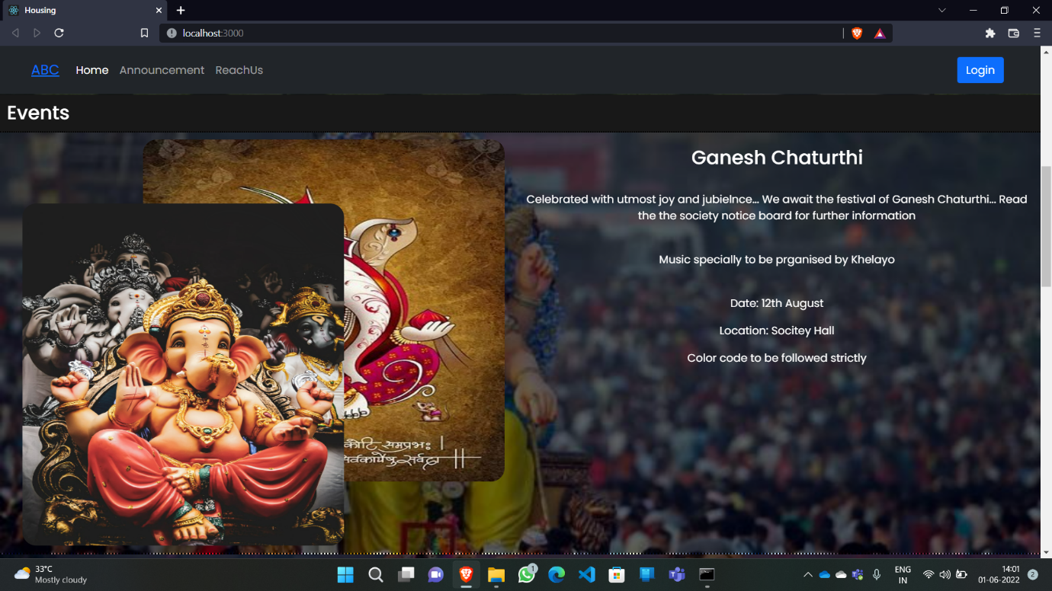

**Landing Page(Events)**

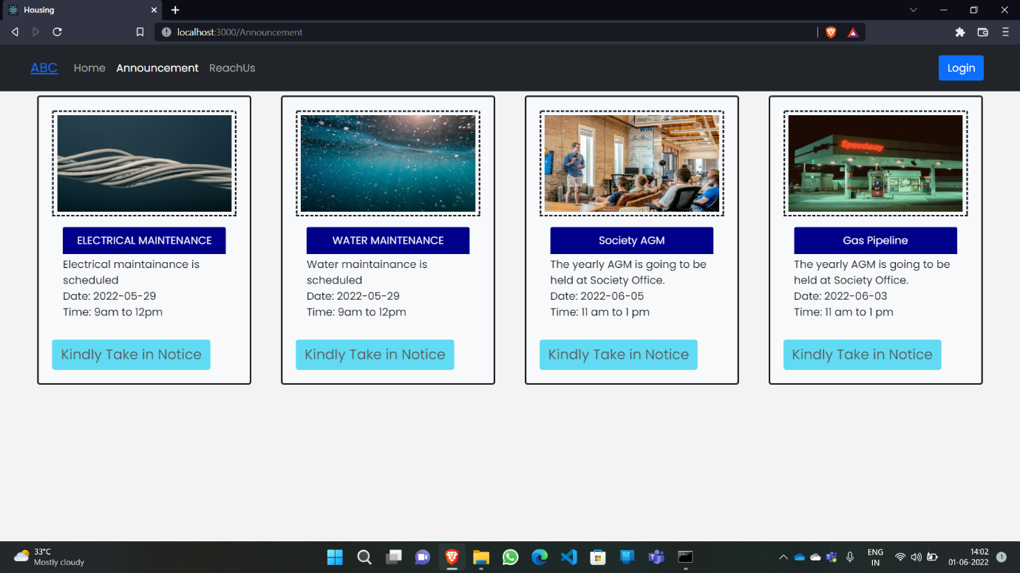

**Announcement**

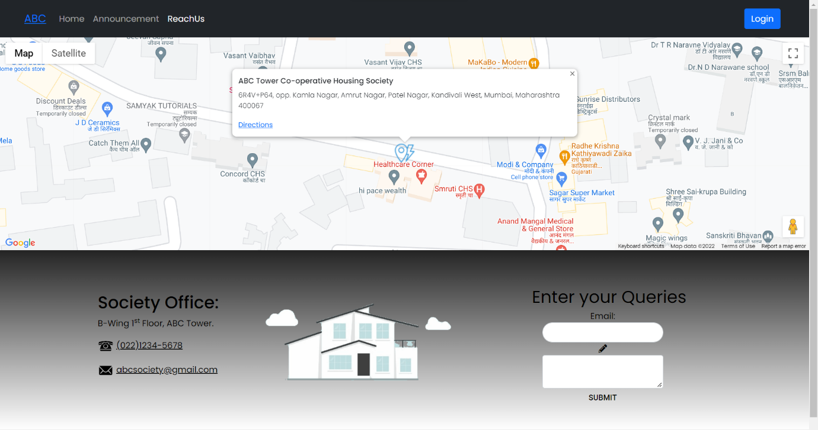

**Reach Us**

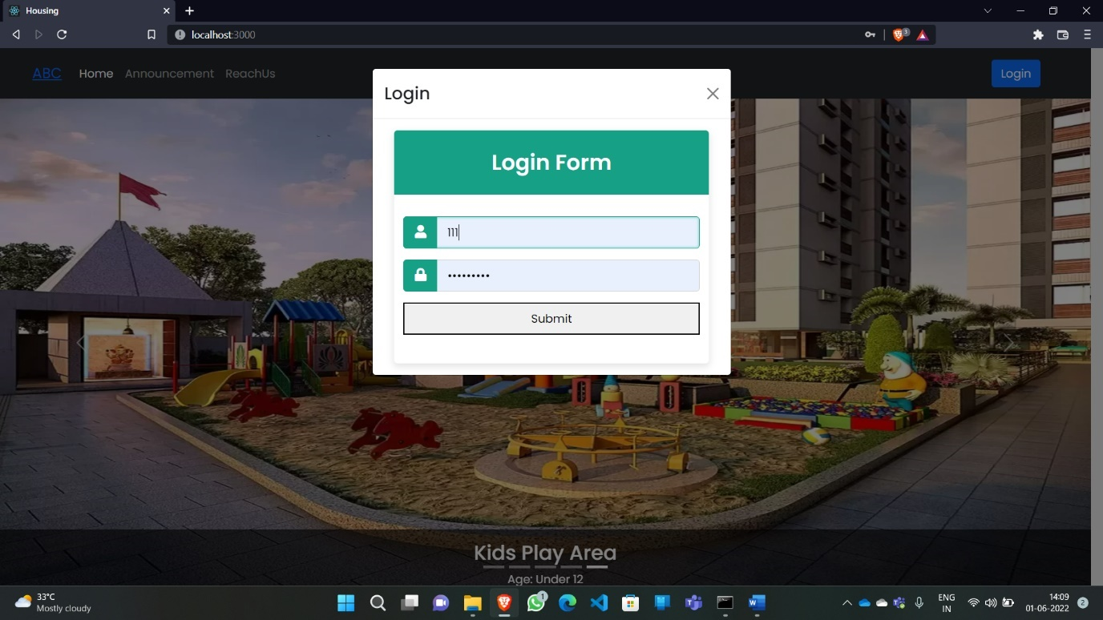

**Login**

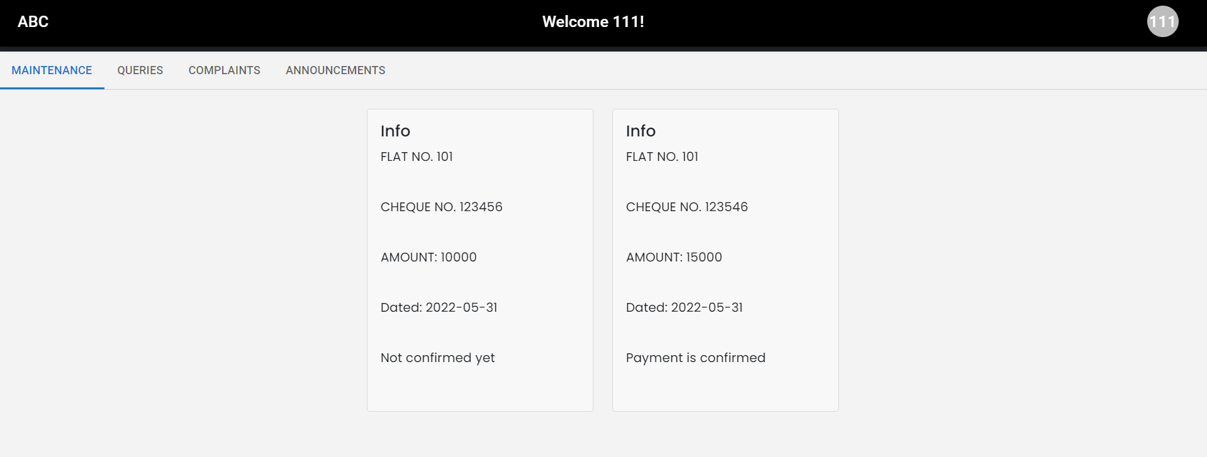

**Admin Dashboard(Maintenance)**

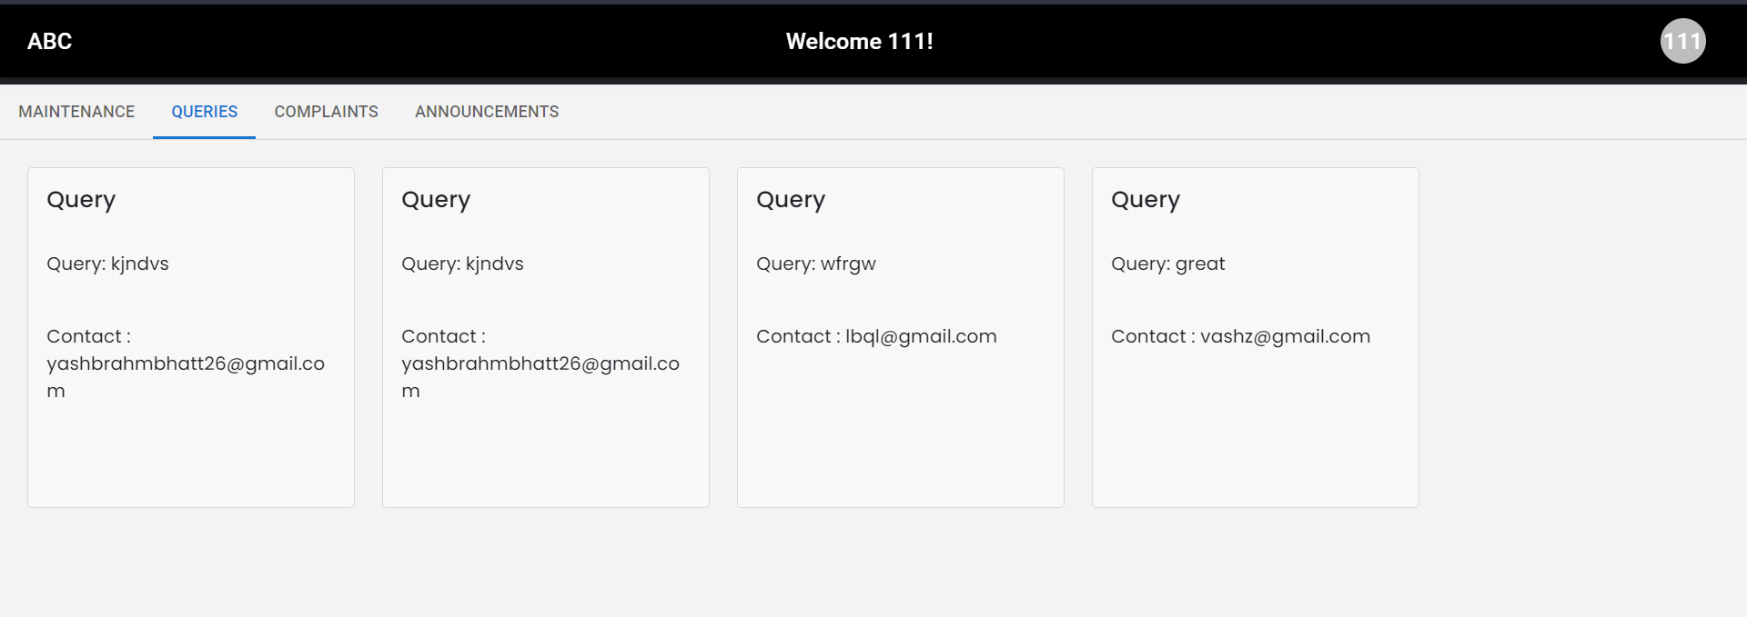

**Admin Dashboard(Queries)**

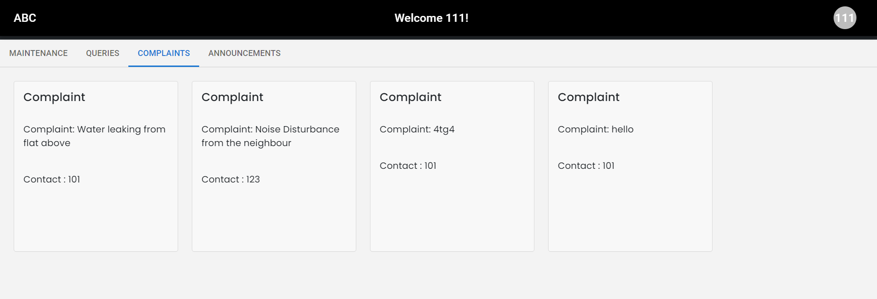

**Admin Dashboard(Complaints)**

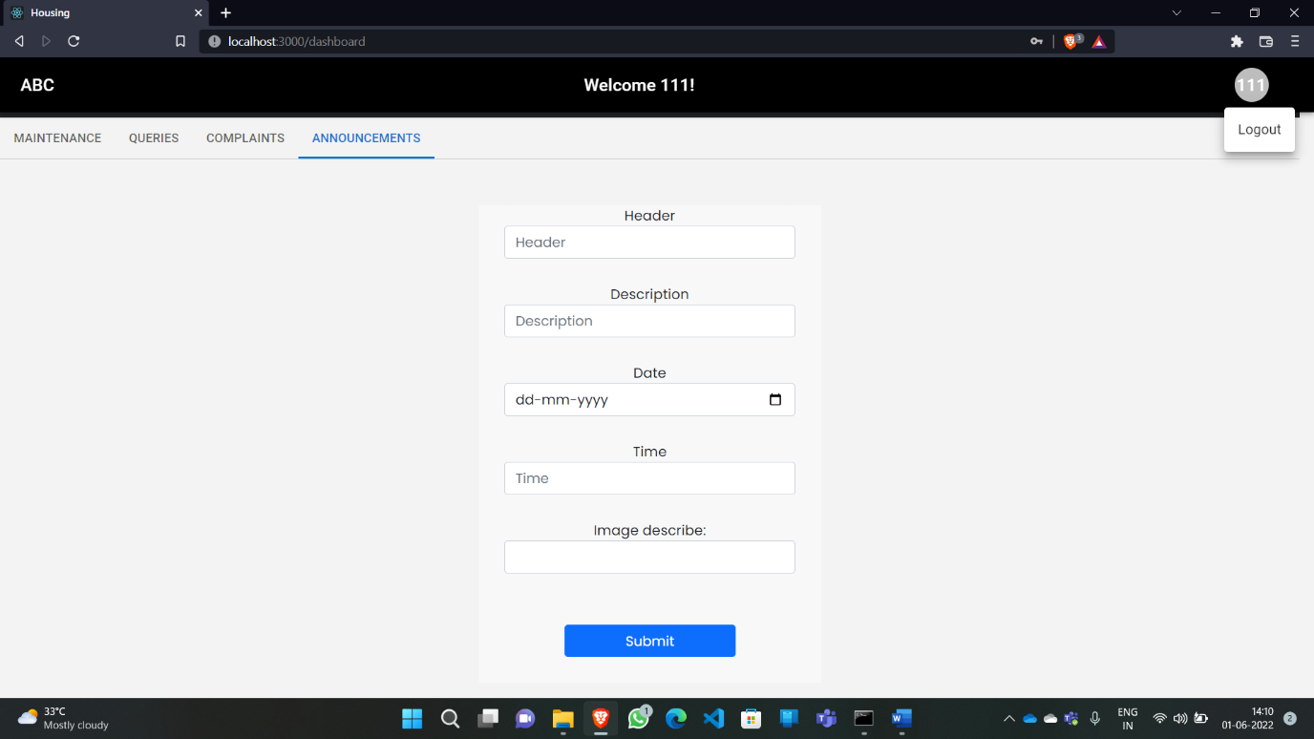

**Admin Dashboard(Announcements)**

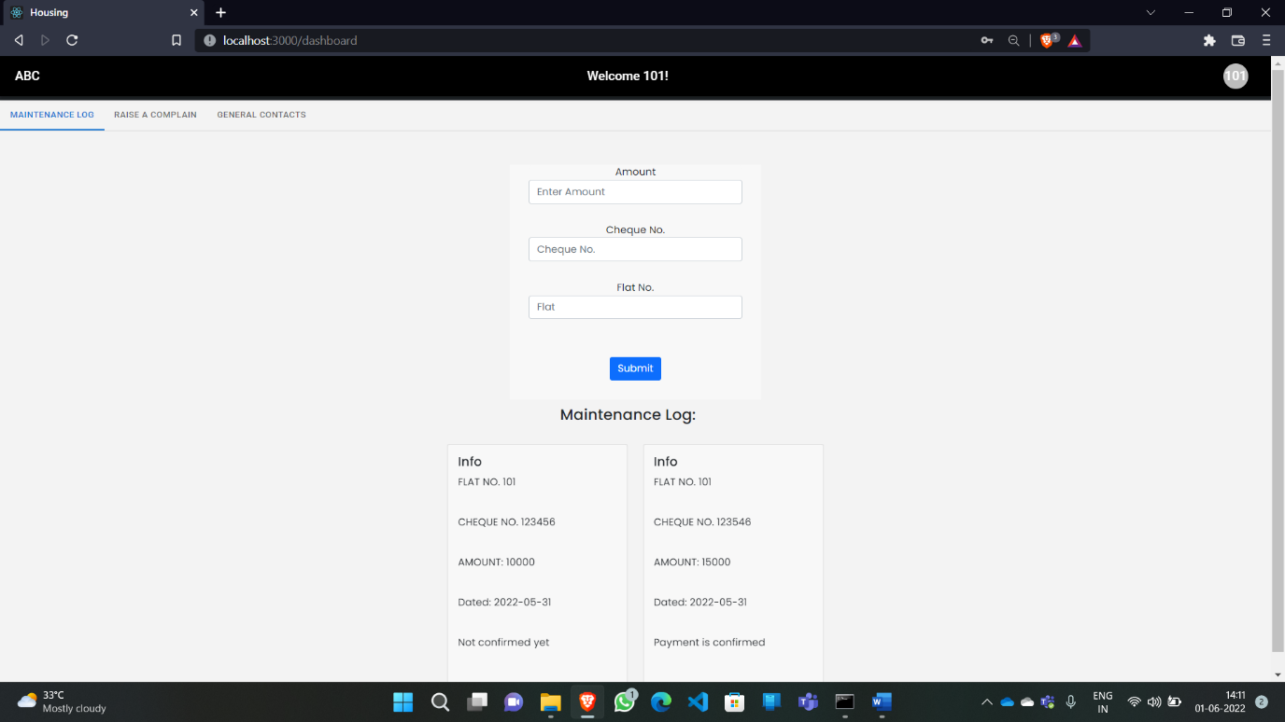

**User Dashboard(Maintenance)**

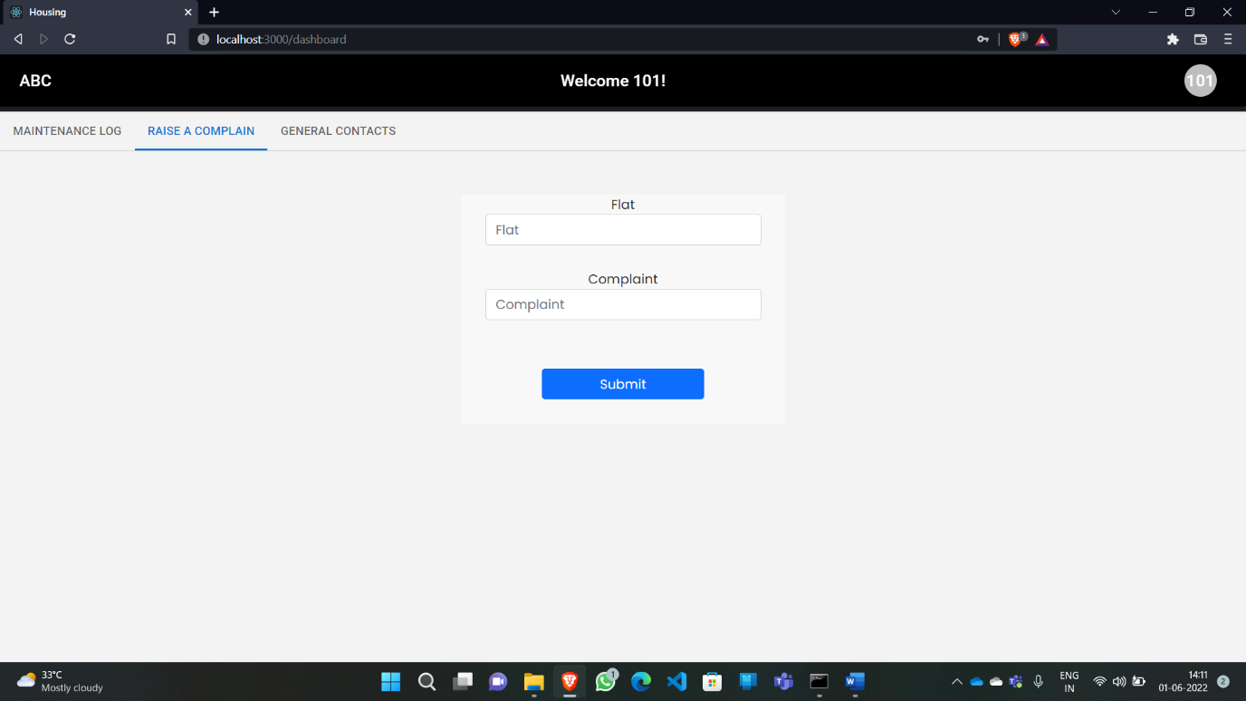

**User Dashboard(Complaint)**

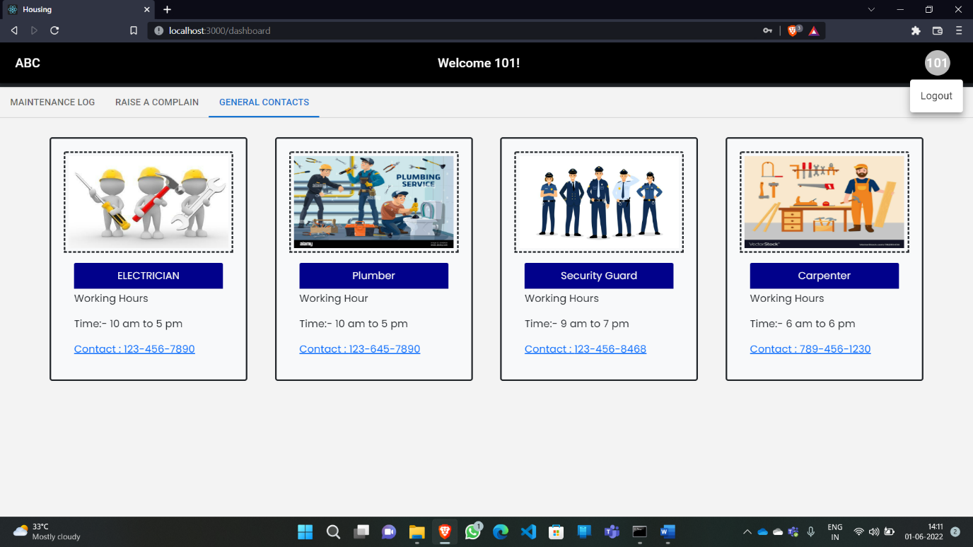

**User Dashboard(Contacts)**

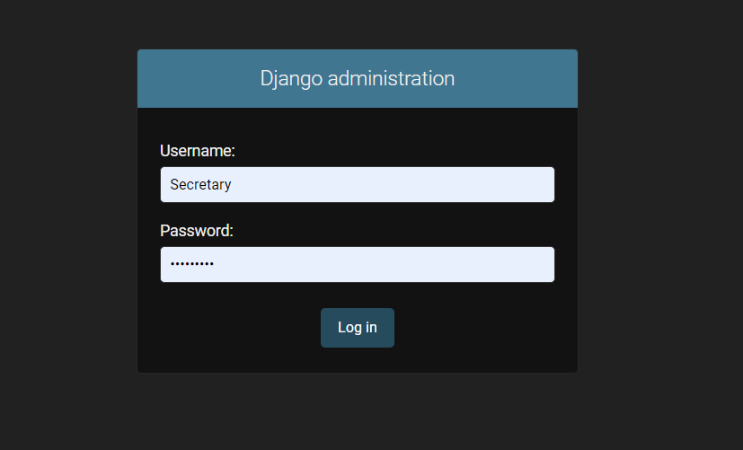

**Admin/Server(Login)**

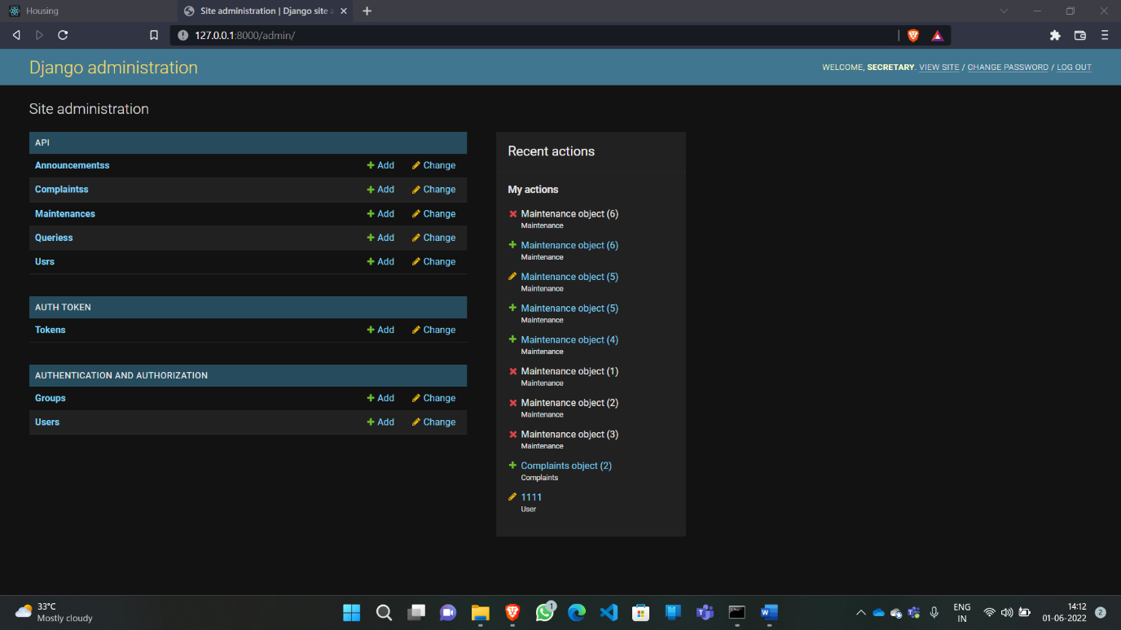

**Django Admin**